AlexNet(Top)

ZFNet(Bottom)

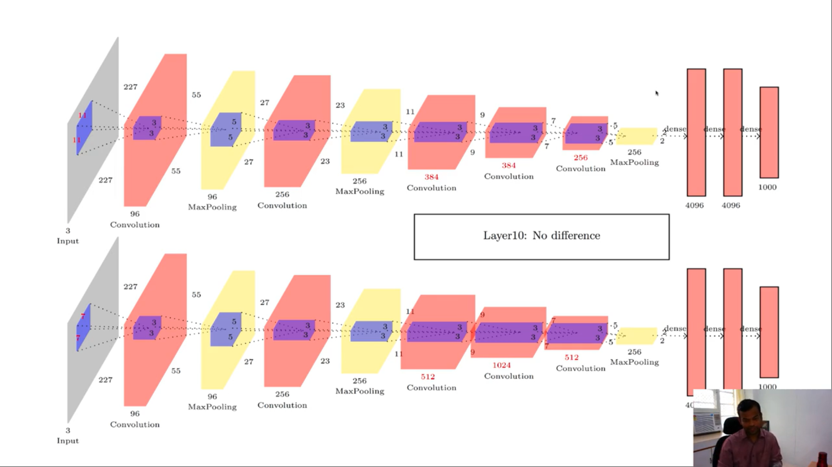

VGGNet

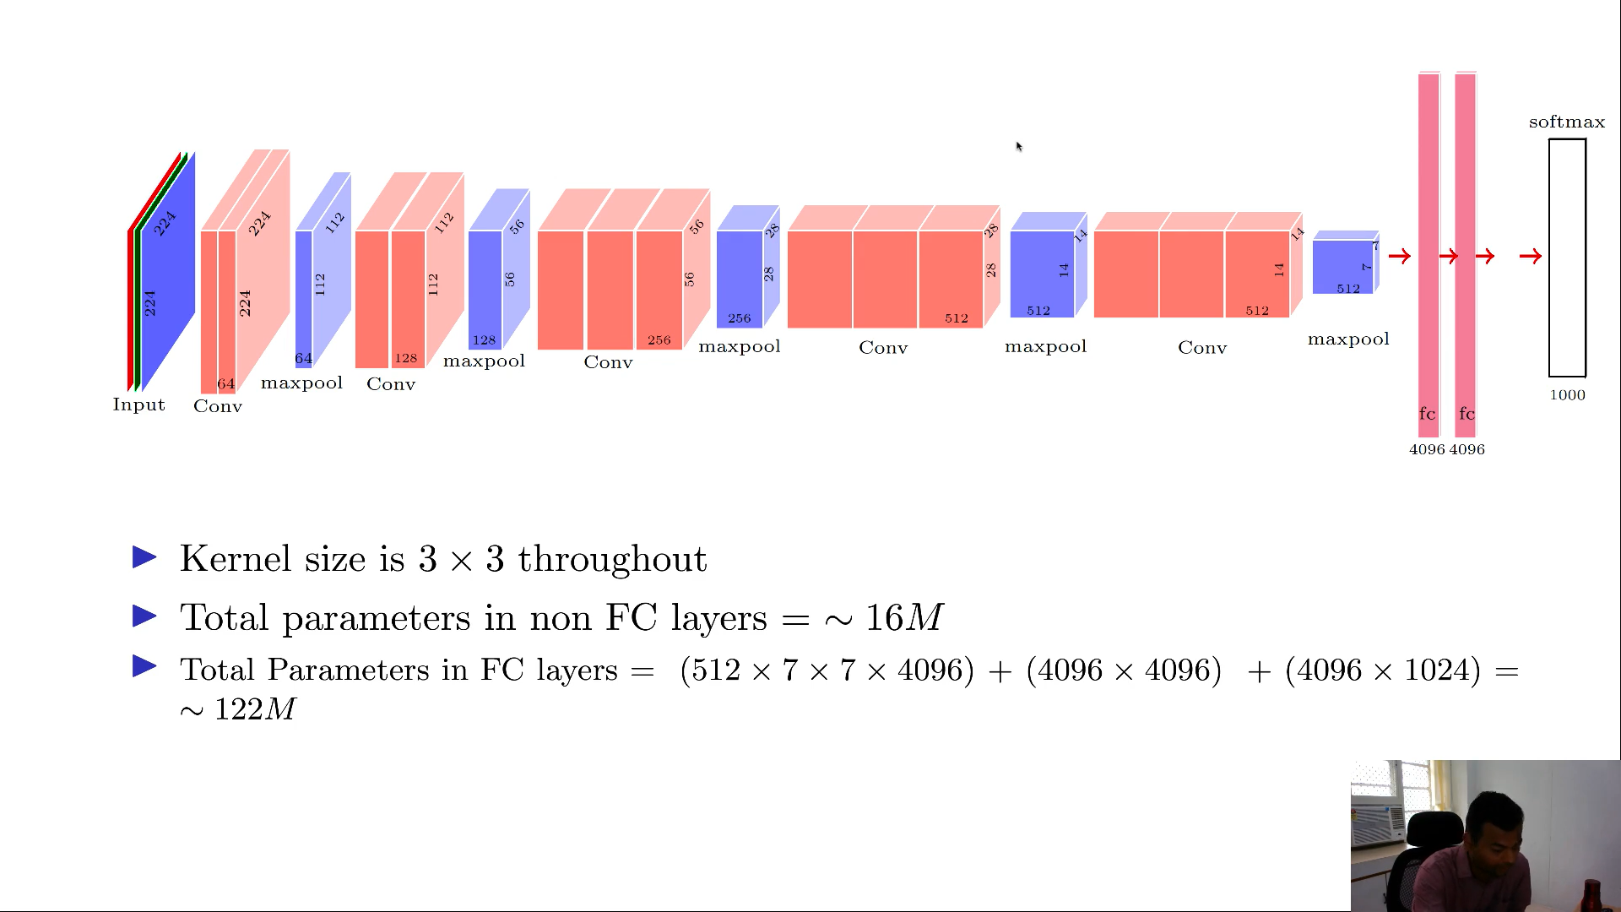

No. of computations at any layer = W x H x F x F x D

So, No. of comp depends on D

So, to reduce depth use 1x1 convolutions

GoogleNet

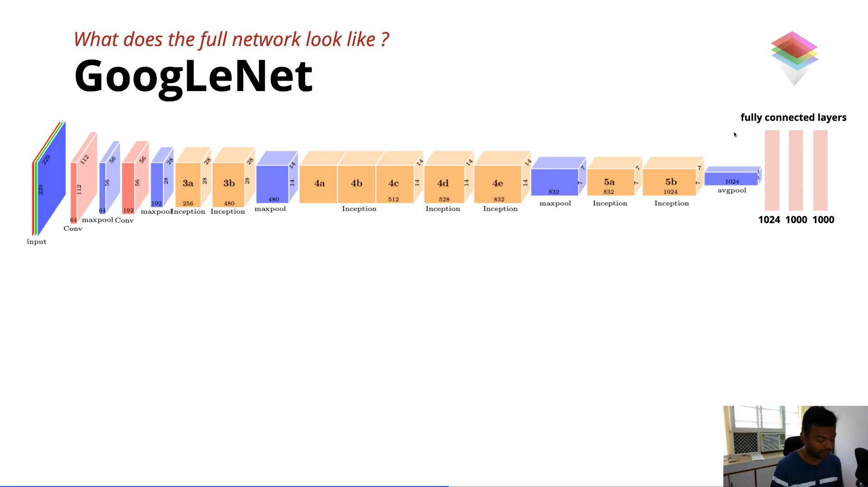

ResNet

